**User Manual**

**Z4**

**Content**

1. Phone layout 1

1.1. Key and Parts 1

2. Getting started 2

2.1. Inserting the SIM & SD card 2

3. Safety Information and Notices 3

3.1. For Your Safety 3

4. Copyrights 7

5. LAVA support and contact information 7

6. LAVA WARRANTY CERITIFICATE 7

©2020. All rights are reserved. No part of this document may be reproduced without permission.

While all efforts have been made to ensure the accuracy of all the contents in this manual, we assume no liability for errors or omissions or statements of any kind in this manual, whether such errors or omissions or statements resulting from negligence, accidents, or any other cause. The contents of this manual are subjected to change without notice.

Protect our environment! We strive to produce products in compliance with global environmental standards. Please consult your local authorities for proper disposal.

**Note:** User Manual is just to guide the users about the functionality of the phone. It is not a certificate of technology. Some functions may vary due to modifications and upgrade of software, or due to print mistake.

# 1. Phone layout

## 1.1. Key and Parts

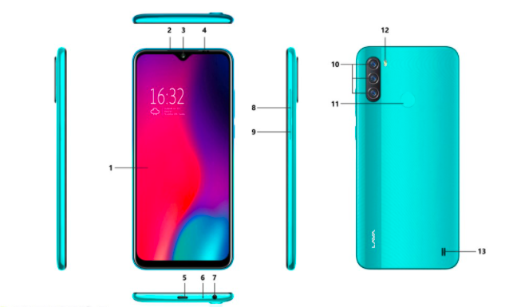

|  |  |  |  |
| --- | --- | --- | --- |
| Label | Key | Label | Key |
| 1 | Screen | 8 | Volume Key |
| 2 | L/P Sensor | 9 | Power Key/Lock Key |
| 3 | Front Camera | 10 | Rear Camera |
| 4 | Receiver | 11 | Fingerprint Sensor |
| 5 | USB Charging slot | 12 | Rear Flash |
| 6 | Mic | 13 | Speaker |
| 7 | Earphone slot |  |  |

# 2. Getting started

Please read the safety instructions in the "Safety Information and Notices" section before use.

## 2.1. Inserting the SIM & SD card

* Use the SIM ejector tool to push into the SIM Eject slot till the SIM tray pops out
* Gently pull the SIM tray out
* Place SIM card and SD card on the respective slots
* Hold the SIM tray upright and push it back into the space till you hear it click inside

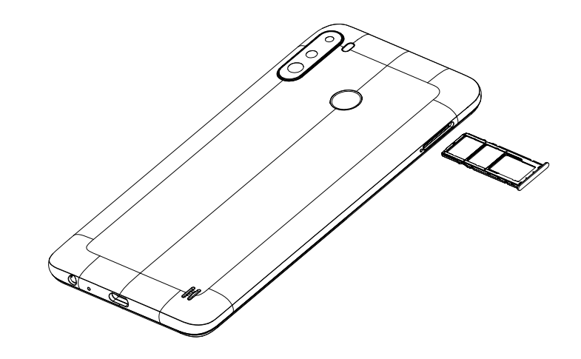

## 

# 3. Safety Information and Notices

## 3.1. For your safety

* Switch off the phone in hospitals and aircraft. Obey any restrictions. Wireless devices can affect the medical treatment and cause interference in aircraft.
* Some medical devices such as hearing aids and pacemaker may be sensitive to external radio frequency emissions. Consult the device manufacturers or your doctor before using the phone around the medical devices.
* Pay special attention to the ring tone volume and vibration settings if you have a heart problem.
* In areas with potentially explosive atmosphere, such as gas stations, fuel or chemical transfer or storage facilities, obey all signs and instructions.
* Your phone will emit radio frequency even in the standby mode. Turn off your phone when so instructed.
* Always obey all the local laws and regulations. Do not use your phone while driving. Use Hands-free operation, if available, and give full attention to driving and to the road. Pull off the road before making or answering a call if you are driving.
* If your phone is lost or stolen, notify your service provider immediately to stop the SIM card from being used.
* To prevent your phone from misuse, lock your SIM card or phone, and change passwords when necessary.
* When you leave your vehicle, take the phone with you or place it in the glove compartment to avoid theft.
* Keep the phone or charger out of reach of children.

**Notes on phone usage**

* Your phone will give off electromagnetic waves. Do not place it near storage medium such as floppy disk.
* Using the phone near television, land phone, radio and office automatic devices may cause interference and affect the function of the mobile phone.
* Keep the phone dry; all kinds of liquid can erode electronic circuit.
* Keep the phone away from extreme temperatures.
* Keep the phone away from fire or a lighted cigarette.
* Do not paint the phone.
* Do not drop the phone or violently crush or shake the phone.
* Do not keep the phone near magnets and other object with magnetism. The phone’s magnetism may clear the information stored on floppy disk, pre-paid phone card and credit card.
* Keep the phone away from hot places where the temperature may exceed 60°C, such as dashboard, windowsill, or areas exposed to direct sunlight.
* Do not disassemble or modify your phone. This can damage the phone, cause leakage and break the internal circuit.
* Use only damp cloth or non-static cloth to clean your phone.
* Do not use alcohol, thinner, benzene or other chemicals or abrasive cleaner to clean your phone.
* The phone will become warm under normal use and while in battery charging.
* Do not leave the phone with the battery empty for a long period of time. This may cause data loss.
* The metal parts of the phone may irritate your skin depending on your health condition.
* Do not put the phone in the back pocket. Sitting on it may damage the phone. Do not put the phone at the bottom of a bag. You may crush it.
* When the vibrate mode is on, place the phone carefully to prevent it from being dropped from a height or being moved to a heat source due to the vibrating.
* Do not press the touch screen with needles, pen point or other sharp objects; it can damage the display and violate the terms and conditions of the warranty.

**Notes on battery usage**

* Keep metal objects (such as coins or key rings) away from the battery to avoid short circuit.
* Do not remove the battery without turning off the phone.
* Do not hold the battery in your mouth. The liquid of the battery can be toxic.
* Embedded battery shall be replaced by authorized dealers. Use only batteries approved by the phone manufacturer; otherwise, it may cause explosion.
* Damage resulting from using un-authorized batteries and chargers will not be covered by the warranty.
* Avoid contact with any leaked liquid of the battery. If it touches your skin, wash your skin with fresh water and go to the hospital immediately.

**Certification Information (SAR)**

* Your phone is designed not to exceed the limits of emission of radio waves recommended by international guidelines. These guidelines include safety margins designed to assure the protection of all persons, regardless of age and health.
* SAR (specific absorption rate) is the unit of body-absorbed RF quantity when the phone is in use. SAR value is ascertained according to the highest RF level generated during laboratory tests.
* The true SAR level during phone usage will be far lower than this level.
* The SAR value of the phone may change depending on factors such as how close you are to a network tower, use of accessories and other enhancements.
* The highest SAR value of the device is less than 1.6W/Kg averaged over 1 gm of human tissue.
* The SAR value may differ depending on national reporting, testing requirements and the network band.

**SAR Recommendations**

* Use a wireless hands-free system (headphone, headset) with a low power Bluetooth emitter.
* Please keep your calls short and use SMS whenever more convenient. This advice applies especially to children, adolescents and pregnant women.
* Prefer to use your cell phone when the signal quality is good.
* Maintain a preferable distance of 15 mm from the device.

**Safety precautions:**

* Use cell phone when the signal quality is good
* Use a wireless hands-free system (Headphone, headset) with a low power Bluetooth emitter
* Make sure the cell phone has a low SAR
* Keep your calls short or send a text message (SMS) instead. This advice applies especially to children, adolescents and pregnant women.

**E-waste Disposal Mechanism**

'E-waste' means waste electrical and electronic equipment (WEEE). In other words, E-waste is a popular, informal name for electronic products nearing the end of their "useful life". For more details about e-waste please refer e-waste rules, 2011 [www.moef.nic.in](http://www.moef.nic.in)

**Dos and Don’ts for disposal of e-waste**

**Dos:**

* Ensure that an Authorized Person repairs your Lava products
* Call Our Local Authorized Collection Centers to Dispose Lava products
* Always drop your used electronic products, batteries or any accessories thereof after the end of their life at nearest Authorized Collection Point or Collection Center.
* Separate the packaging material according to responsible waste disposal options and sorting for recycling.
* Always remove the battery from the product, when you do not intend to use the product anymore it in future.

**Don’ts:**

* Do not Dismantle your Lava Product on your own
* Do not give your e-waste to Scrap Dealer/ Rag Pickers.
* Do not dispose-off the e-waste in landfills
* Never dump E-waste in garbage bins.
* Do not dispose of your product at municipal waste bins or rooms.
* Do not throw used batteries into household waste.

**Consequences of improper handling and disposal of E-Waste**

* Improper disposal of waste prevents natural resources from being re-used.
* Some waste contains hazardous chemicals and if not disposed of properly may release toxins into the soil and water, and also releases greenhouse gases into the environment
* If e-waste is not properly disposed of, it can be a threat to health and well-being of humans and animals and it also has adverse effect on the environment.
* Placing of batteries or devices on or in heating devices, such as microwave, ovens, stoves, or radiators and improper disposal of batteries may lead to explosion.
* If the battery terminals are in contact with metal objects, it may cause a fire.

For more details on how to dispose of your Lava products at the end of life, please refer the list of our Services Centers on Pan basis on our website

[www. lavamobiles.com](http://www.lavamobiles.com)

# 4. Copyrights

Google is a trademark of Google LLC.

# 5. LAVA support and contact information

LAVA support and contact Information

Visit: [**http://www.lavamobiles.com**](http://www.lavamobiles.com) for additional information on downloads and services related to your LAVA product.

To check for the nearest LAVA service center location for maintenance services, please visit:

[**http://www.lavamobiles.com/support**](http://www.lavamobiles.com/support)

**Service Center number**

1860-500-5001

(Available from Monday to Saturday, between 10:00AM to 6:00PM)

For any service related enquiries please contact us at: [lavacare@lavainternational.in](mailto:lavacare@lavainternational.in)

# 6. LAVA WARRANTY CERITIFICATE

**Limited Warranty:**

LAVA international Ltd. (LAVA) provides limited warranty for your mobile phone and original accessories delivered with your mobile phone (hereinafter referred to as “product”)

The warranty period for the transceiver is one (1) years and for battery, data cable, charger and headset is six (6) months from the date of purchase.

**LAVA Warranty:**

Subject to the conditions of this Limited Warranty, LAVA warrants a product to be free from defects in design, material and workmanship at the time of its original purchase by you, and for a subsequent period of one (1) years for transceiver and six (6) months for battery, data cable, charger and headset.

You shall have no coverage or benefits under this warranty in the event that any of the following conditions are applicable:

* The product has been subjected to abnormal use or conditions, improper storage, exposure to excessive moisture or dampness, exposure to excessive temperature, unauthorized modification, unauthorized repair (including but not limited to use of unauthorized spare parts in repairs), abuse, accidents, Acts of God, spills of food or liquids, improper installation
* You have not notified Lava of the defect in the product during the applicable warranty period.
* The product serial no. code or the accessories date code has been removed, defaced or altered.
* The product has been used with or connected to an accessory (i) Not supplied by Lava or its affiliates, (ii) Not fit for use with the product or (iii) Used otherwise than in manner intended.
* The seals of the product’s battery enclosure have been broken or shown evidence of tempering or the product’s battery has been used in equipment other than that for which it has been specified usable by LAVA.
* All plastic surfaces and all other externally exposed part that is scratched or damaged due to normal use.
* To get maximum of your new product, we recommend you to:
* Read the guidelines for safe and efficient use as mentioned in the manual.
* Read the terms and conditions of your Lava warranty in the manual.
* Keep your original receipt; you will need it for warranty services if asked to produce.
* In case Lava product needs service, please visit the nearest Lava service centers given in the service guide. Please visit our Website [www.lavamobiles.com](http://www.lavamobiles.com) for updated list of Authorized Service Centers near to your location.
* Important note: for your warranty to be valid, all information on the warranty certificate has to be completed including the stamp from the authorized distributor/retailer.
* All warranty information, product features and specifications are subject to change without notice.